The Arsenal

Vision (Small Project)

Version 1

Revision History

|  |  |  |  |
| --- | --- | --- | --- |
| **Date** | **Version** | **Description** | **Author** |
| 09/09/2019 | 1 | Initial draft | Brent Hedden |
| 9/23/2019 | 1.1 | Edited and Appendix A added | The Arsenal |
|  |  |  |  |
|  |  |  |  |

Table of Contents

1. Introduction 3

1.1 References 3

2. Positioning 3

2.1 Problem Statement 3

2.2 Product Position Statement 3

3. Stakeholder and User Descriptions 3

3.1 Stakeholder Summary 3

3.2 User Summary 3

3.3 User Environment 3

3.4 Summary of Key Stakeholder or User Needs 3

3.5 Alternatives and Competition 3

4. Product Overview 3

4.1 Product Perspective 3

4.2 Assumptions and Dependencies 3

5. Product Features 3

6. Other Product Requirements 3

Vision (Small Project)

# **1.** **Introduction**

The purpose of this document is to provide an overview and analysis of the issues that the Student Recreation Center is having. The Arsenal, Inc. will be providing potential solution to these listed issues.

## **1.1** **References**

McHugh, R. (2019, May 22). The True Price of Storing Documents In an Office. Retrieved from <https://www.recordnations.com/2017/02/price-you-pay-to-store-documents-in-office/>

# **2.** **Positioning**

## **2.1** **Problem Statement**

|  |  |
| --- | --- |
| The problem of | Reporting of data collection |
| affects | Management and decision makers |
| the impact of which is | Data is collected, but nothing more is done with it |
| a successful solution would be | Be able to take action based on realistic data |

## **2.2** **Product Position Statement**

|  |  |
| --- | --- |
| For | Employees of Student Recreational Center |
| Who | Efficiently within the Facility needs |
| The (product name) | is a website and user interface |
| That | Product will increase security and decrease manual entries |
| Unlike | Previous models |
| Our product | Free and will be on UofL servers. |

# **3.** **Stakeholder and User Descriptions**

The main stakeholders that are affected by the issues presented will be all employees of the SRC, UofL, and members of the SRC. The employees main requirement is to create a more efficient and organized environment to work in. Our objective with the employees are to make it easier for them to keep records for specific functions they are trying to implement. This will also make it easier on management for the SRC in order to generate more reports and create better workflow. For UofL, the goal is to make the SRC something that will stand out to not only potential members, but also to potential students looking to attend UofL. Making the SRC appear as its own entity instead of simply a branch of the college could possibly increase profit and decrease the cost to the university. For students, it’s all about giving them the best experience possible. Although, they may benefit the least from the implementations, they could potentially benefit from the effects of the changes we are looking to make. Other stakeholders include maintenance companies and possible developers for a website or app.

## **3.1** **Stakeholder Summary**

|  |  |  |
| --- | --- | --- |
| Name | Description | Responsibilities |
| SRC Employees | These individuals are the targeted users that will be using the new implementations to their already existing systems. | Their role is to test and implement the systems into their everyday activity to provide feedback for quality control. |
| SRC Management | SRC management will be listening to our iterations to provide us with directions to improve our vision on the new systems. | Their role is to approve the appropriate changes and suggestions made by us to improve their existing systems. |
| University of Louisville | UofL is the governing body that approves for the changes that will be made to the university. | Their role will be to ensure that the systems will create a positive impact on the SRC and the university as a whole. |
| SRC Members | The members represent the individuals that won’t be directly affected by the changes, but potentially can be in the future. | Their role will be to populate the reports with data whether it be for the locker rentals, memberships, and engagement. |
| Maintenance Companies | Maintenance companies represent an outside entity that handles the maintenance of equipment. | Their role is to also benefit from automated systems that include the equipment and the television power control. |
| Developers | Developers represent the maintenance and upgrading of the website or app. | Their role is to take and learn the new system and maintain it in order for it to run in the most efficient way possible. |

## **3.2** **User Summary**

|  |  |  |  |
| --- | --- | --- | --- |
| Name | Description | Responsibilities | Stakeholder |
| SRC Members | They represent the user data that will be collected for different reports that will be generated throughout the entire process. They allow the SRC to see how many people are in a specific area and have information stored the connects to their locker rentals and membership fees. | Their responsibility as a user is to populate the reports using normal functions. | SRC Employees |

## **3.3** **User Environment**

* The SRC currently relies heavily on the use of paper with all of their systems whether it be locker rentals, memberships, and other records they keep. There is nothing wrong with using paper, however, using it creates a larger probability of losing and mislabeling information that is key for the SRC. There is not a lot of people involved with completing specific tasks, typically each task is completed by only one individual.This isn’t really the problem as much as the time it takes to complete the task. Something as simple as looking for someone’s name within a stack of paper takes one minute to a minute and a half. This may seem insignificant, but can be decreased drastically. A unique environment constraint that SRC employees deal with is the inconsistent nature of a gym. Tracking where all members can be very difficult because everyone does not have the same workout plan each day. These factors can change day-by-day which makes it hard to track such a dynamic environment. Currently, we have no knowledge of the system platforms and applications being used by the SRC for their database purposes, they seem to only use paper. They do, however, use applications for their maintenance that can be integrated with the new systems that we create that can be collaborated on.

## **3.4** **Summary of Key Stakeholder or User Needs**

|  |  |  |  |  |
| --- | --- | --- | --- | --- |
| Need | Priority | Concerns | Current Solution | Proposed Solutions |
| Increased Employee Productivity | 4 | Nothing guarantees an increase in employee productivity. | Assigning more employees to specific tasks on a shift. | Having less people on a shift and assigning more tasks to individuals. |
| Decrease or eliminating paper | 1 | SRC may not want to drift away from an existing method. | Using paper to keep track of records for members of the SRC. | Using an electronic database system that can keep track of all of these specific records. |
| Creating independent website | 5 | UofL may not want to fund an independent website. | The SRC “website” is a section of the university's main website. | Creating a website separate from the university's main website. |
| Maintenance Systems | 3 | New systems may not integrate with the current maintenance system. | They currently use their own maintenance system. | Integrate our system with the current maintenance system to make it more efficient. |
| Online Payments | 6 | This will have a cost behind it and many people may not trust it. | Currently, they show no interest in using an online payment system. | Implement an online payment system that makes it more convenient to pay off locker and membership fees. |
| Count Sheets | 2 | These need to be as accurate as possible and is highly susceptible to human error. | They go around and enter this data by hand on paper. | Create a more efficient way to keep track of how many members are in a specific area electronically. |

## **3.5** **Alternatives and Competition**

* The main competitor we are facing is maintaining the status quo. The phrase if it isn’t broke don’t fix it can apply here. The concern here is that the stakeholders will find all of these potential implementations redundant, overbearing, and overall, costly and will steer them away from making any of these changes. They have been doing it the same way for such a long time, that we are afraid that they will hear us out, but ultimately keep it as a suggestion and remain with the same system. Their current system works, however, we have the potential to upgrade it and lead it to many great improvements.

# **4.** **Product Overview**

[This section provides a high level view of the product capabilities, interfaces to other applications, and system configurations. This section usually consists of two subsections, as follows:

• Product perspective

• Assumptions and dependencies]

## **4.1** **Product Perspective**

The integration of a Single Website that allows online payment, opens the opportunity for the organization to engage in e-commerce to sell SRC branded things and even allow registrations for classes and activities online.

## **4.2** **Assumptions and Dependencies**

They are willing and able to pay for a website

Only want a product that could satisfy their needs.

It could increase their revenue and reduce wage expenses.

# **5.** **Product Features**

· Product would be open source

· Data entry friendly

· Online system might be a very good way to increase productivity and allow customers to get membership from anywhere at the website

· Increased productivity could also reduce wage expenses for SRC because they could reduce unnecessary staff

# **6.** **Other Product Requirements**

[At a high level, list applicable standards, hardware, or platform requirements; performance requirements; and environmental requirements.

Define the quality ranges for performance, robustness, fault tolerance, usability, and similar characteristics that are not captured in the Feature Set.

Note any design constraints, external constraints, or other dependencies.

Define any specific documentation requirements, including user manuals, online help, installation, labeling, and packaging requirements.

Define the priority of these other product requirements. Include, if useful, attributes such as stability, benefit, effort, and risk.]

**Appendix A**

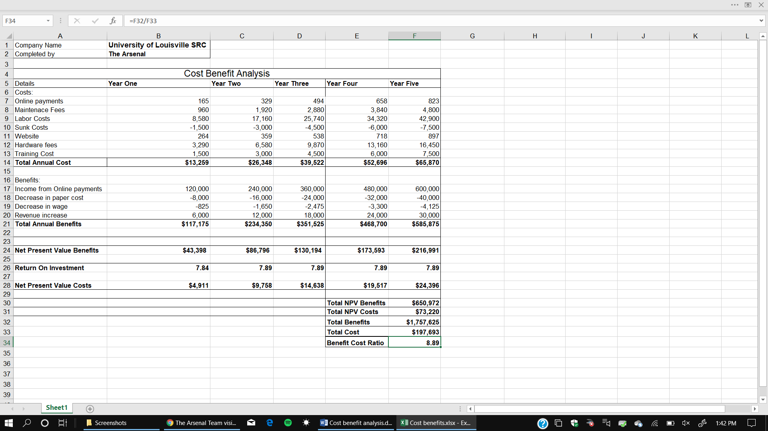

**Costs**

· **Online payments:** we estimate that roughly the SRC has an average of 500 people per week and multiple it by the online payment fee by each transaction.

· **Maintenance Fees:** According to Google a professional website takes about $80 per month to maintain it.

· **Labor cost:** we estimated that majority of the fitness are students, so they are part time which means they work about 20 hours a week. We took 20 hours and multiple it by 52 weeks to give us the gross hours per year. Then we multiple by 8.25.

**Benefits**

· **Paper Cost:** According to record nation average annual cost to store documents in an office is about $8,000.

· **Income from Online payments:** Membership cost around $240 per year for members so took that and multiple it by people per year which was 500.

· **Decrease in Wage:** estimated that if the works worked two hours less and 2 hours shorted. We would multiply 2 hours by 50 weeks and by the amount they get paid hourly.

· **Revenue increase:** We took the year rate of $240 and multiple it by 25 new members as if the rate was to go up.

· **NPV:** Calculated by using the current inflation of 1.7% and using the total annual benefits/cost per year

· **ROI:** calculated by taking total annual benefits per year and subtracting it by total annual costs and then dividing it.

· **Benefit Cost Ratio:** Calculated by taking total benefits and diving it by total costs.